Railway Crossing Status
Project Agenda: Build an application to communicate the status of railway crossings in advance

Scenario:
James Tech Pvt. Ltd. hired you as a Full Stack Developer. They intend to develop an application that can communicate the status of a railway crossing well to the public in advance. You are asked to develop a prototype of the application. The application prototype will then be presented to the relevant stakeholders for budget approval. Your manager has set up a meeting where you are asked to present the following in the next 15 working days (2 weeks):
- Specification document: application capabilities, appearance, and user interactions
- Java EE concepts to be used in the project
- Frontend and backend technologies to be used
- Database to be used

Tasks you will perform will include:
- Develop the application using Java EE
- Work with Java Server Page to create a frontend
- Implement Servlet to develop a backend
- Perform CRUD operations using JDBC or Hibernate for MySQL

Operations to be implemented in the application:
- Features and operations for the public:
- Create an Account: Registration and login operations for public users
- Fetch the details of the railway crossings and display them on the frontend for the public
- Display the status of the railway crossing: open or closed
- Option to search railway crossings
- Option to mark a railway crossing as favorite
- View that list of Favourite Railway Crossings

- Government level operations:
- Login to a specified admin account to access a dashboard
- Add a railway crossing to the application
- Delete a railway crossing from the application
- Search for a specific railway crossing
- Update the status of a railway crossing: open and close
- Navigation option to access all features with ease

Flow and features of the application:
- Code to display the welcome screen. It should display:
- Application name and the developer details
- The details of the user interface such as options displaying the user interaction information
- An option asking to navigate to either the public or government sections
- The first option is a separate webpage for the public:
- It must provide an option to authenticate the user. The user can create an account with basic details like name, email, password, and login if the account exists.
- It should fetch the details of railway crossings.
- With each railway crossing listed, it must display the status of the railway crossing
- An option to search should be implemented to search for a railway crossing by name, like how we search on Google.
- User can mark a railway crossing as a favorite.
- You must display the list of favorite railway crossings separately.
- The second option is used by the Railway Department to manage railway crossings. It should include:
- A form through which an administrator can navigate to the government dashboard using a pre-created email and password in the database.
- Add a railway crossing to the application:
- You can create a form in HTML that can send an HTTP POST request to the Servlet to add the details to the database. Remember to use JDBC or Hibernate as a backend framework.

- Consider the Railway Crossing Model to have the following attributes:
- Name
- Address (can have latitude and longitude as well)
- Landmark
- Train schedules (probably the timings as a textual description)
- Details of the person in charge of the railway crossing
- Status
- Delete a railway crossing from the application
- Display a list of railway crossings with an option to delete them within the Table View
- Return a suitable message upon successful deletion of the railway crossing
- Option to update the status of the railway crossing
- It can have the default state as open
- The state can be updated to closed when a train is approaching the crossing
- A proper navigation bar can be created using HTML5 to facilitate easier access to the mentioned options.
- Exceptions should be handled for invalid input
- Implement the appropriate concepts such as exception handling, collections, and searching techniques for source code optimization and increased performance

Tools and technologies:
- Eclipse or IntelliJ
- Java
- Servlets
- JSP
- JDBC or Hibernate
- MySQL
- Apache Tomcat
- Search and Sort techniques
- Specification document

Requirements to be met:
Please ensure you have accomplished the following by the end of your application completion:
- End user authentication to access the application
- Listing of railway crossing sites with status
- Favourite railway crossings for end users
- Government user authentication to access admin Dashboard
- CRUD operations for Railway Crossing Management
- Update Status of railway crossing site

Screenshots:
User end

Task 1: Create an account or Register
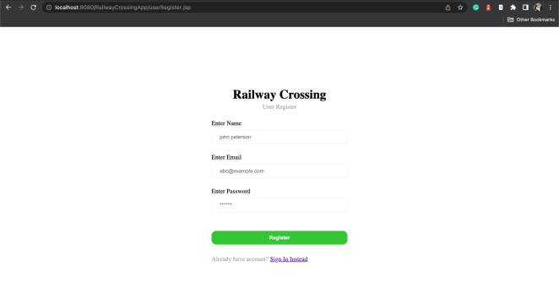

Task 2: Log in
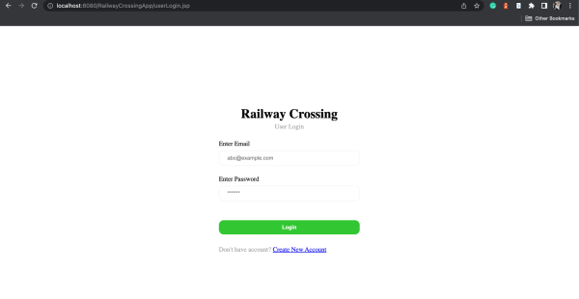

Task 3: Display Railway crossing data

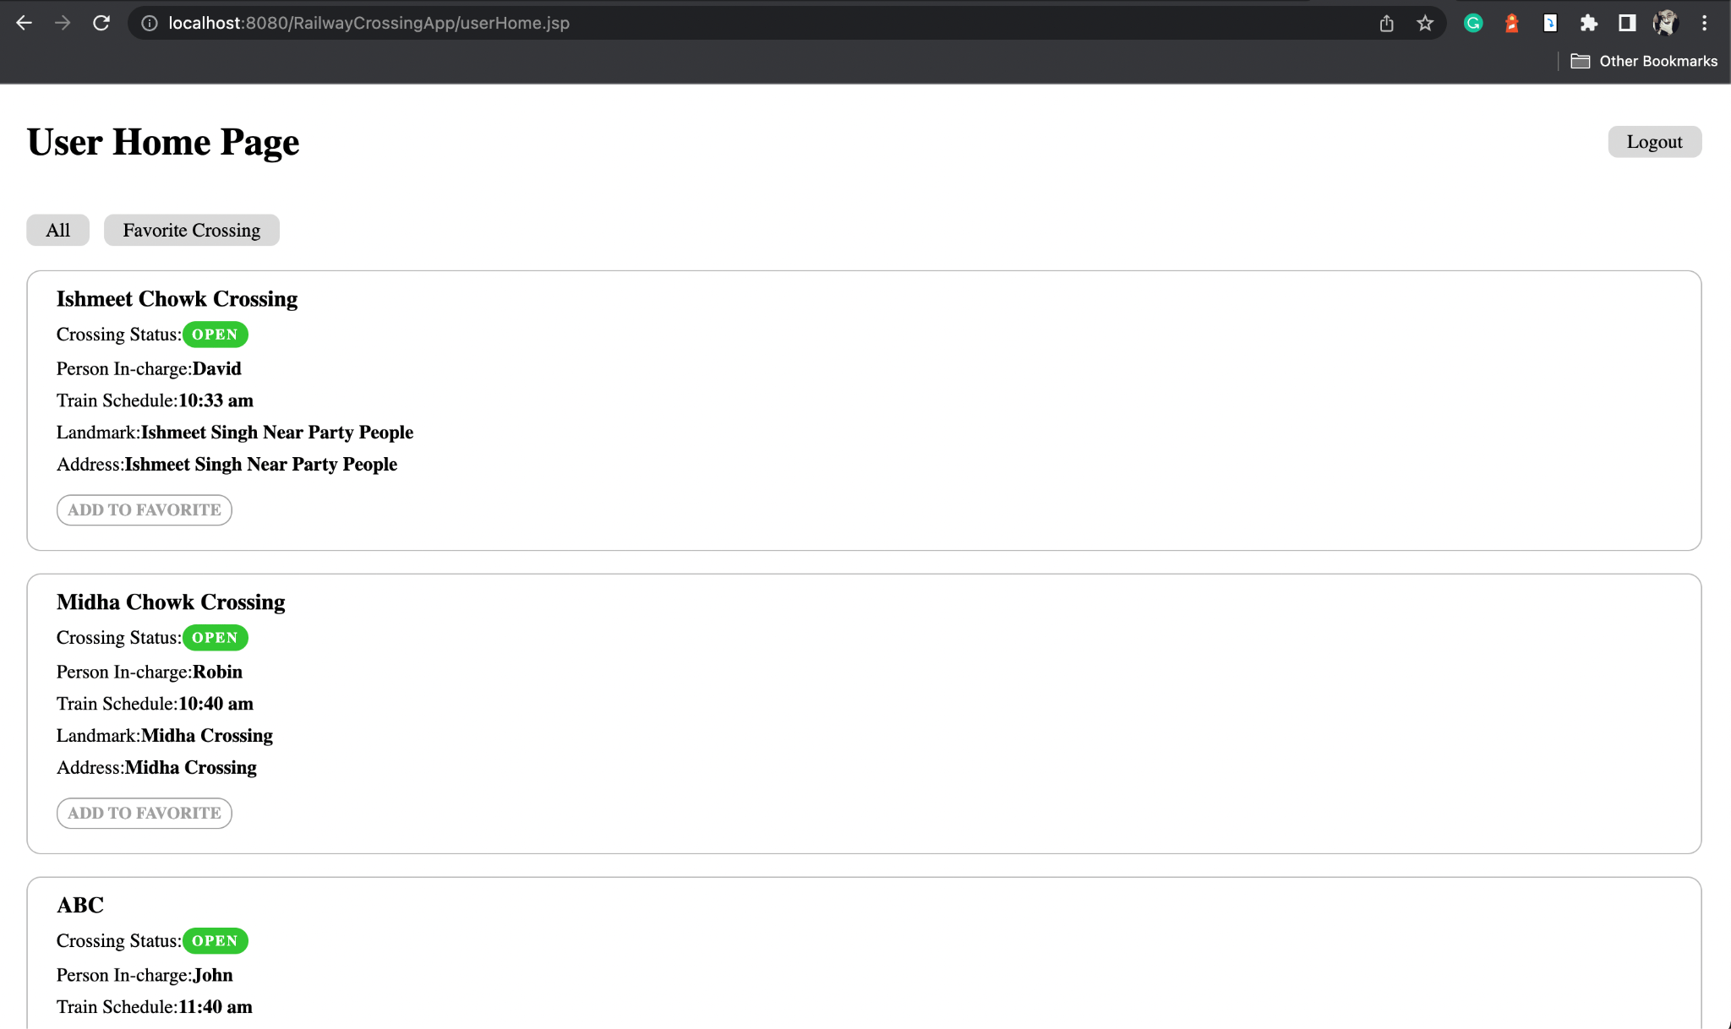

Task 4: Railway crossing status

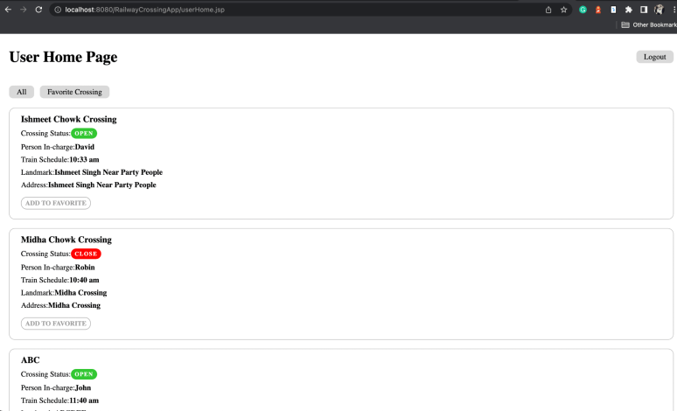

Task 5: Search Railway Crossing

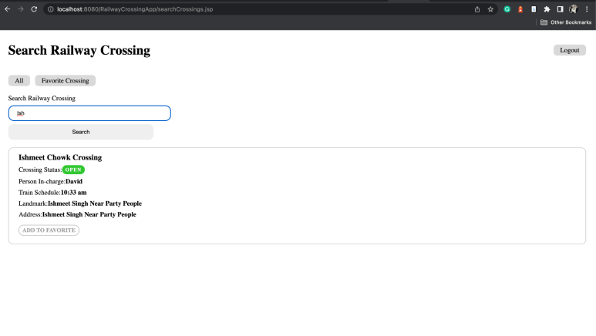
Task 6: Mark railway crossing as Favourite
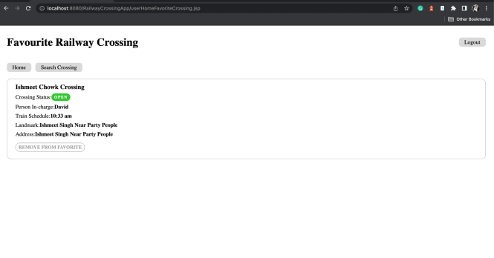

Admin-End:

Task 7: Add Crossing

Task 8: Manage Crossings

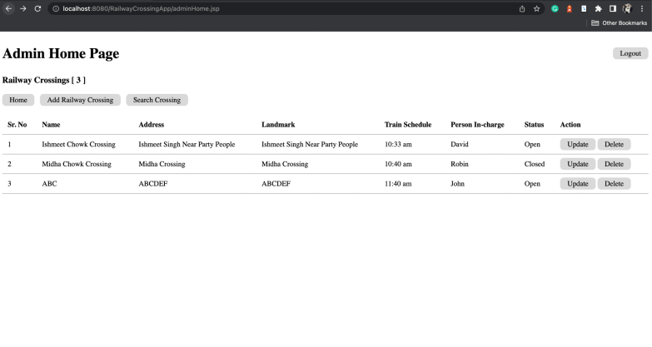

Task 9: Delete a Crossing

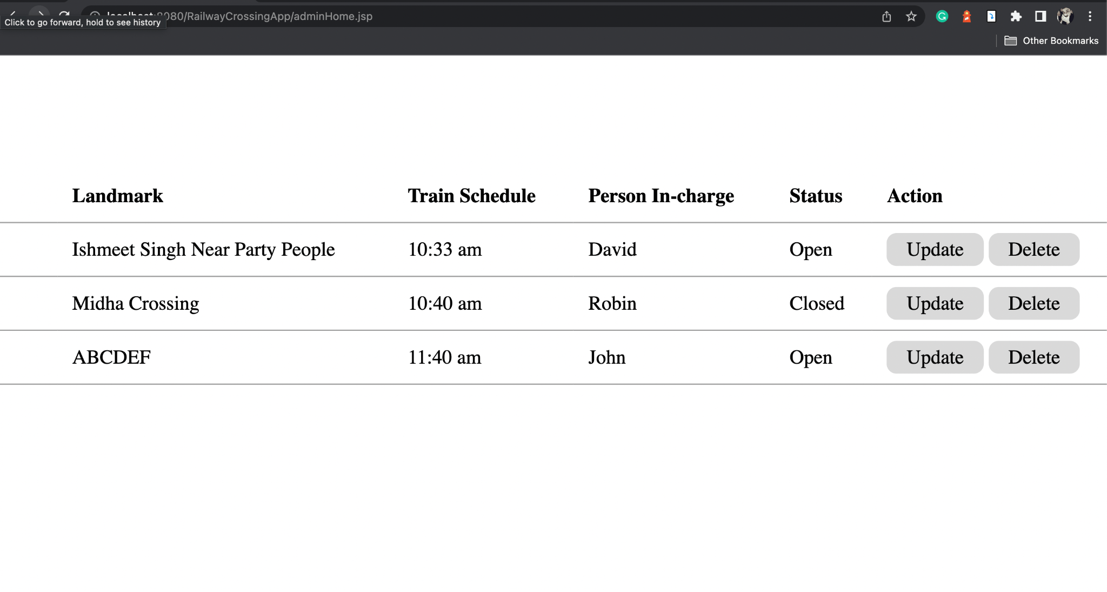

Task 10: Update Crossing details

